|  |
| --- |
|  |
| 新概念 3 册 |
| Lesson21 Daniel Mendoza |

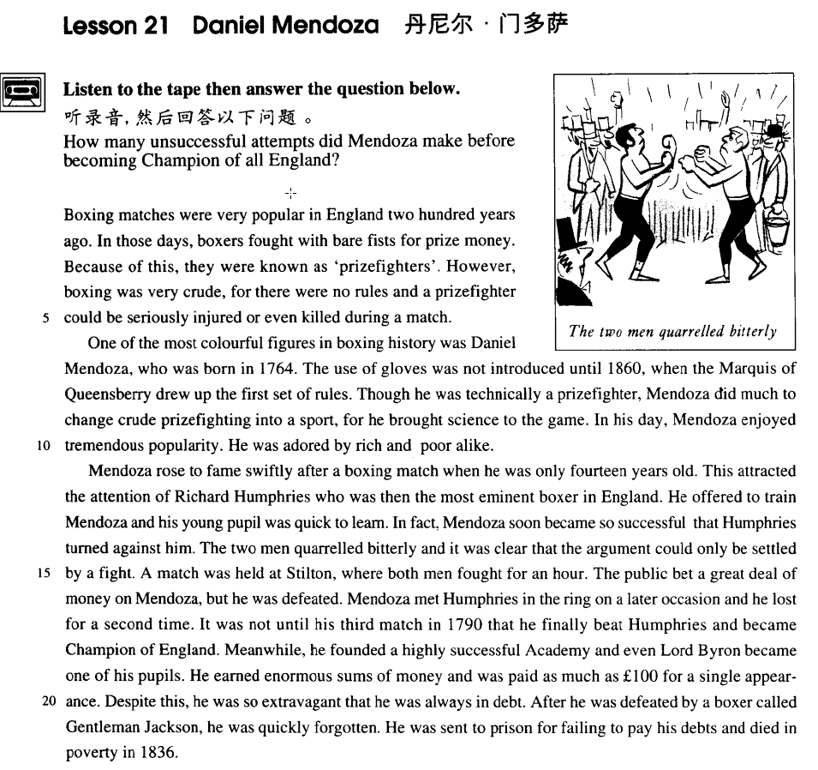

课文

Boxing matches were very popular in England 200 years ago.

两百年前，拳击比赛在英国非常盛行。

In those days, boxers fought with bare fists for prize money.

当时，拳击手们不戴手套，为争夺奖金而搏斗。

Because of this, they were known as 'prizefighters'.

因此，他们被称作“职业拳击手”。

However, boxing was very crude, for there were no rules and a prizefighter could be seriously injured or even killed during a match.

不过，拳击是十分野蛮的，因为当时没有任何比赛规则，职业拳击手有可能在比赛中受重伤，甚至丧命。

One of the most colourful figures in boxing history was Daniel Mendoza, who was born in 1764.

拳击史上最引人注目的人物之一是丹尼尔.门多萨，他生于1764年。

The use of gloves was not introduced until 1860, when the Marquis of Queensberry drew up the first set of rules.

1860年昆斯伯里侯爵第一次为拳击比赛制定了规则，拳击比赛这才用上了手套。

Though he was technically a prizefighter, Mendoza did much to change crude prizefighting into a sport, for he brought science to the game.

虽然门多萨严格来讲不过是个职业拳击手，但在把这种粗野的拳击变成一种体育运动方面，他作出了重大贡献。是他把科学引进了这项运动。

In his day, Mendoza enjoyed tremendous popularity. He was adored by rich and poor alike.

门多萨在的全盛时期深受大家欢迎，无论是富人还是穷人都对他祟拜备至。

Mendoza rose to fame swiftly after a boxing match when he was only 14 years old.

门多萨在14岁时参加一场拳击赛后一举成名。

This attracted the attention of Richard Humphries who was then the most eminent boxer in England.

这引起当时英国拳坛名将理查德.汉弗莱斯的注意。

He offered to train Mendoza and his young pupil was quick to learn.

他主动提出教授门多萨，而年少的门多萨一学就会。

In fact, Mendoza soon became so successful that Humphries turned against him.

事实上，门多萨不久便名声大振，致使汉弗莱斯与他反目为敌。

The two men quarrelled bitterly and it was clear that the argument could only be settled by a fight.

两个人争吵不休，显而易见，只有较量一番才能解决问题。

A match was held at Stilton, where both men fought for an hour.

于是两人在斯蒂尔顿设下赛场，厮打了一个小时。

The public bet a great deal of money on Mendoza, but he was defeated.

公众把大笔赌注下到了门多萨身上，但他却输了。

Mendoza met Humphries in the ring on a later occasion and he lost for a second time.

后来，门多萨与汉弗莱斯再次在拳击场上较量，门多萨又输了一场。

It was not until his third match in 1790 that he finally beat Humphries and became Champion of England.

直到1790年他们第3次对垒，门多萨才终于击败汉弗莱斯，成了全英拳击冠军。

Meanwhile, he founded a highly successful Academy and even Lord Byron became one of his pupils.

同时，他建立了一所拳击学校，办得很成功，连拜伦勋爵也成了他的学生。

He earned enormous sums of money and was paid as much as ￡100 for a single appearance.

门多萨挣来大笔大笔的钱，一次出场费就多可达100英镑。

Despite this, he was so extravagant that he was always in debt.

尽管收入不少，但他挥霍无度，经常债台高筑。

After he was defeated by a boxer called Gentleman Jackson, he was quickly forgotten.

他在被一个叫杰克逊绅士的拳击手击败后很快被遗忘。

He was sent to prison for failing to pay his debts and died in poverty in 1836.

他因无力还债而被捕入狱，最后于1836年在贫困中死去。

词汇讲解

* **boxing** ['bɒksɪŋ] n. 拳击运动

**boxing match** 拳击比赛

**boxing gloves** 拳击手套

**boxing ring** 拳击台

**boxer** 拳击手

**prizefight** （古代的）拳击比赛

**prizefighter** （古代的）拳击手

**referee** 裁判

* **bare** [beə(r)] adj. 赤裸的

**bare-headed** 没有戴帽子的

**bare-chested** 光膀子的

**bare-legged** 光着腿的

**bare-assed** 光着屁股的

**bare floor** 没有铺地毯的地板

**bare mountains** 荒山野岭

**with one’s bare hands** （习语）赤手空拳

* Wu Song killed the tiger **with his bare hands**.

**naked** ***adj.*** 裸体的；无装饰的；无证据的；直率的

* He was **naked** to the waist.

**the naked eye** 裸视

**nude** ***adj.*** 裸的，裸体的；无装饰的；与生俱有的

* She once posed **nude** for a magazine.
* **marquis** ['mɑ:kwɪs] n. 侯爵

**英国贵族阶层：**

**duke** 公爵

**marquis** 侯爵

**earl** 伯爵

**viscount** 子爵

**baron** 男爵

**aristocracy *n.*** 贵族；贵族统治；上层社会；贵族政治

**aristocrat** ***n.*** 贵族

**noble** ***n.*** 贵族

**nobleman *n.*** 贵族

**lord** 阁下（对贵族或高级官员的尊称）

* Lord Byron

**sir** n. 对爵士 (**knight**) 的尊称

* Sir John Hawkwood
* **technically** ['teknɪkli] adv. 技术上；严格地说

表示“**技术上**”：

* a **technically** brilliant pianist.
* It is **technically** possible to produce a human being by cloning.

表示“**严格地说**”：

**technically (speaking)**

**strictly speaking**

* **Technically (speaking),** the whale isn’t a fish.
* **Strictly speaking**, the spider isn’t an insect.
* **popularity** [pɒpju'lærəti] adv. 流行，普及；名望
* the increasing **popularity**（留下） of organic food
* The president’s **popularity**（名望） has declined considerably.

**be popular with / among …** 受到了…的欢迎

* **走遍美国**
* She was in love with Donald McGrath, the quarterback on our football team.
* Football players are always **popular** with the ladies.

**fame** （褒义）***n.*** 名声，名望；传闻，传说

* All he thinks about is **fame** and gain.

**renown** （褒义）***n.*** 声誉；名望

**celebrity** （褒义）***n.*** 名人；名声

**name** （中性）***n.*** 名称，名字；姓名；**名誉**

**reputation** （中性）***n.*** 名声，名誉；声望

* The restaurant has a very **good / bad name / reputation.**

**famous** ***adj.*** 著名的；极好的，非常令人满意的

**well-known** ***adj.*** 著名的；众所周知的；清楚明白的

**renowned** ***adj.*** 著名的；有声望的

**noted** ***adj.*** 著名的；显著的；

**notable** ***adj.*** 值得注意的，显著的；著名的

**legendary** ***adj.*** 传说的，传奇的

* ‘the most valiant soldier and most **notable** leader, Signor Giovanni Haukodue’
* He was known to us all as Dickie and his eccentricity had become **legendary** long before he died.

**celebrated *adj.*** 著名的；有名望的

**eminent *adj.*** 杰出的；有名的；明显的

* the most **eminent** boxer in England

**infamous *adj.*** 声名狼藉的；无耻的；邪恶的；不名誉的

**notorious *adj.*** 声名狼藉的，臭名昭著的

* **adore** [ə'dɔ:(r)] v. 非常喜欢，爱慕；崇拜
* She **adores** her only son.
* I absolutely **adore** chocolate.

**like**

**love**

**care** for ***v.*** 照顾；关心；**喜欢**

**fancy** ***vt.*** 想象；**喜爱**；设想；自负 ***vi.*** 幻想；想象

* I did not **fancy** the idea and I reluctantly followed Robert out of the room.

**be the apple of one’s eye** 掌上明珠

* His youngest daughter **is the apple of his eye.**
* **老友记**
* Oh look who it is, my husband, the **apple of my eye.**

表达“**爱上某人**”：

**fall in love with sb.**

**lose one’s heart to sb.**

**be mad / crazy about sb.** 疯狂的爱上

* The way to a man’s heart is through his stomach.

表达“**单相思**”：

**carry a torch for sb.**

**have a crush on sb.**

* **老友记**
* Monica **had such a crush on him**. Yeah, she used to kiss his poster every night before she went to bed.
* Oh! I used to do that too!
* **bet** [bet]v. 打赌

**bet … on …** 在…押了多少钱

* He **bet** all his money **on** the black horse.

**I bet = I am certain** 我确定

* **听力真题：**

A．Tom's apartment probably costs more than the man's.

B．The man's place is becoming more expensive.

C．Her apartment is better than the man's.

D．She wants to see Tom's new apartment.

M: I’ve just been over to my friend Tom’s new apartment. It's much bigger than my place.

W: But more expensive I bet.

Q: What does the woman mean?

Answer: (A) Tom's apartment probably costs more than the man's.

**you bet = certainly** 当然是这样

* **走遍美国**
* Pete Waters, RFD Number 1, Chesterton. You know him?
* Do I know Pete Waters? **You bet** I do! He was my roommate in college.
* **托福听力真题：**

1. He'll go if the woman goes too.
2. He doubts he'll be able to go.
3. He's too tired to go.
4. He's eager to go.

W: Are you still planning to go to the concert?

M: **You bet** I am.

Q: What does the man say about the concert? Answer: (D) He's eager to go.

* academy [ə'kædəmi] n. 专科学校，学院
* West Point is a famous military **academy**.

**Academy Award (Oscar)** 学院奖

**academic *adj.*** 学术的；理论的；学院的

**academic year** 学年

**academic research** 学术研究

课文讲解

# （第一段）

# Boxing matches were very popular in England 200 years ago.

知识点（一）

**race** 竞速比赛

* a car / boat/ horse / swimming race
* It looked as if there would be an exciting race across the Channel.

**match**【英】 / **game**【美】 对垒比赛

* a boxing / basketball / football / volleyball match / **game**
* Boxing **matches** were very popular in England two hundred years ago.

**contest** 强调由裁判打分的比赛

* a speech / beauty / dance **contest**

**open** 公开赛

* the US **Open**

**tournament** ***n.*** 锦标赛，联赛；比赛

**championship** ***n.*** 锦标赛；冠军称号；冠军的地位

**games** ***n.*** 比赛（game的复数形式）

* the Olympic **Games**
* the Goodwill **Games**

# In those days, boxers fought with bare fists for prize money.

知识点（一）

**in those days** 想当初（必须加in）

* Though **in those days**, traveling was not as easy as it is today, steam boats carried thousands of visitors across the Channel from Europe.
* **In those days** wandering minstrels were welcome everywhere.

时间状语“**当今，现如今**”： 指当今没有介词“in”

**these days**

**today**

**nowadays**

**in this day and age**

* **These days**, people who do manual work often receive far more money than people who work in offices.

知识点（二）

**with bare fists**  赤手空拳

**with naked fists** 赤手空拳

**with one’s bare hands**（强调没有武器）赤手空拳

# Because of this, they were known as 'prizefighters'.

知识点（一）

表示“**因为**”连词：

**because** … 连词

**since** … 表“因为”是连词

**as**… 表“因为”连词

**for** … 表“因为”既可以是连词，也可以是介词，不能在句首，放在主句后面

**in that**… 连词，不能在句首，放在主句后面

**now (that)** … 表“因为”，同时又强调“现在”

* **Now that** a tunnel has been built through the mountains, the Pass is less dangerous, …….

表示“**因为**”介词：

**because of** …

**by reason of**…

**due to** …

**owing to** …

**thanks to** …

**on account of** …

* **听力真题：**

A．She doesn’t like the professor very much.

B．She doubts class will be canceled.

C．She doesn’t want to attend the conference.

D．She wonders whether the professor is an accountant.

M: Do you think professor Smith will cancel class **on account of** the special conference?

W: Not likely.

Q: What does the woman mean?

Answer: (B) She doubts class will be canceled.

知识点（二）

**know A as B** 把A成为B

* He soon made a name for himself and came to **be known** to the Italians **as** Giovanni Acuto.
* He was known to us all as Dickie and his eccentricity had become legendary long before he died.

**refer to A as B** 把A成为B

* People who work in offices **are** frequently **referred to as** ‘white-collar workers’ for the simple reason that they usually wear a collar and tie to go to work.

**call A B** 把A成为B

* From now on, he will wear a suit all day and others will **call him 'Mr. Bloggs'**, not 'Alf'.

**address A as B** 把A成为B

* **老友记**
* Elizabeth: This is my father, Paul Stevens. Dad, this is Ross Geller.
* Ross: It’s great to meet you Paul.
* Paul: I usually prefer Elizabeth’s boyfriends to **address** me **as** Mr. Stevens.
* Ross: Of course, of course, Mr. Stevens.
* **课后题Lesson4 page29**

12．He wanted to be ___A___ ‘Mr. Bloggs’, not ‘Alf. (11.15-16)

(a) **addressed as** (b) named (c) cried out (d) shouted

# However, boxing was very crude, for there were no rules and a prize-fighter could be *seriously injured* or *even killed* during a match.

知识点（一）

表示“**野蛮，残酷，暴力**”：

crude ***adj.*** 粗糙的；天然的，未加工的；粗鲁的

..., boxing was very **cruel**, … ***adj.*** 残酷的，残忍的；使人痛苦的，让人受难的；无情的，严酷的

..., boxing was very **brutal**, … ***adj.*** 残忍的；野蛮的，不讲理的

..., boxing was very **violent**, … ***adj.*** 暴力的；猛烈的

..., boxing was very **bloody**, … ***adj.*** 血腥的；非常的；嗜杀的，残忍的；血色的

知识点（二）

be *seriously injured*  受到重伤

* 课文写法替换：**suffer**
* … a prizefighter could **suffer a serious injury** or even be killed during a match.

# （第二段）

# One of the most colourful figures in boxing history was Daniel Mendoza, who was born in 1764.

**colorful**: interesting, exciting, vivid ***adj.*** 华美的；有趣的；富有色彩的

**figure**: character, personality ***n.*** 数字；**人物**；图形；价格；（人的）体形；画像

* I just wanna be a person, not a **personality**（名人）.
* **课后题**

8．One of the most ___A___ in boxing history was ... (11.6-7)

(a) **vivid personalities** (b) famous people (c) painted images (d) imaginative characters

# The use of gloves was not introduced until 1860, when the Marquis of Queensberry drew up the first set of rules.

知识点（一）

**introduce** v. 开始推行；开始采用

* New safety measures will be introduced next month.

知识点（二）

名词正式表达

* You can **use** my laptop freely.
* The **use** of my laptop is welcome.

知识点（三）

**draw up** 起草

* I’ve **drawn up** a list of candidates that I’d like to interview.

知识点（四）

**… not … until …, when …** 直到…才

# Though he was technically a prize-fighter, Mendoza did much to change crude prize-fighting into a sport, *for he brought science to the game*.

**do much / a lot / a great deal to …** 在…做出了很大贡献

**do little to …**没有什么贡献

**do nothing to …** 完全没用

**change … into …** 把…**变**成…

**exchange … for …** 把…**换**成…

* **造句**：尽管严格地说只是一本书，但圣经在把这个粗鄙的世界变成一个文明世界方面却做出了很大贡献，因为它给人类带来了信仰 (faith)。
* Though it is technically a book, the Bible does much to change the crude world into a civilized one, for it brings faith to humanity.

# In his day, Mendoza enjoyed tremendous popularity. He was adored by rich and poor alike.

知识点（一）

**somebody's day** 某人鼎盛时期

* Every dog has **his day**.
* Don’t be disappointed: **your day** will come.

知识点（二）

enjoye 享有

* …, for it **enjoyed** a high level of civilization.
* **enjoy** tremendous popularity
* Jay Chou **enjoys** tremendous popularity among the young.

知识点（三）

**the** rich 富人

**the** poor 穷人

rich and poor （两种以上可以去掉定冠词the）

young and old （两种以上可以去掉定冠词the）

**the** rich and powerful (一个定冠词指一种人) 既有钱又有权

知识点（四）

**alike**: in the same way

* The climate here is always hot, summer and winter **alike**.

知识点（五）

**idol / icon** 偶像

* He was an **idol / icon** of that times.

# （第三段）

# Mendoza rose to fame swiftly after a boxing match when he was only 14 years old.

**rise to fame** 成名，出名

* She first **rose to fame** as a singer at the age of 16.
* **The rise to fame** was swift.
* **课后题**

10． Mendoza’s ___A___ to fame was noted by Richard Humphries. (11.1 1-12)

(a) rise (b) rose (c) raise (d) claim

**make a name for oneself** 成名

* He soon **made a name for himself** and came to be known to the Italians as Giovanni Acuto.

**become famous overnight** 一夜成名

* With the success of their first record, they **became famous overnight.**

# This attracted the attention of Richard Humphries who was then the most eminent boxer in England.

表达**“吸引了某人的注意”**

**attract / draw / catch / capture / arrest one’s attention / the attention of sb.**

# He offered to train Mendoza and his young pupil was quick to learn.

**offer to do** 主动提出做某事

* In times of peace, when business was bad, Hawkwood and his men would march into a city-state and, after burning down a few farms, would **offer to go** away if protection money was paid to them.

**pupil**: apprentice 课文上下文指“学徒”

指“学生”：

**pupil** 小学生

**student** 中学生/大学生

**freshman** 大一新生

**sophomore** 大二学生

**junior** 大三学生

**senior** 大四学生

**alumnus** 校友

**alumni** 校友

# In fact, Mendoza soon became so successful that Humphries turned against him.

知识点（一）

**turn (sb.) against …** 与某人反目成仇

* The wicked woman is trying to **turn the boy against his father.**

知识点（二）

… soon became **so** successful **that** Humphries became jealous of him.

… soon became **so** successful **as to** arouse Humphries’ jealousy.

* **课后题**

11．Humphries soon became ___A___ Mendoza’s success. (11.13-14)

(a) jealous of (b) disinterested in (c) revolted by (d) changed by

# The two men quarrelled bitterly and it was clear that the argument could only be settled by a fight.

**It is / was clear */* obvious */* apparentthat …**

* The rope had been cut, so **it was** ***obvious*****that** the lamb had been stolen.

# A match was held at Stilton, where both men fought for an hour.

**语法**：前半句的末尾是后半句的成分，并列句改成状语从句，形式上的定语从句，发挥并列句的作用。

A match was held at Stilton, **and both men fought for an hour there**.

# The public bet a great deal of money on Mendoza, but he was defeated.

表达“失败”

…, but he was **defeated**.

…, but he was **beaten**.

…, but he **failed**.

…, but he **lost**.

课文中“**失败**”的替换：

* The public bet a great deal of money on Mendoza, but **he was defeated.** Mendoza met Humphries in the ring on a later occasion and **he lost** for a second time. It was not until his third match in 1790 that **he finally beat Humphries** and became Champion of England.
* ~~We finally won that team.~~ **X** 错误表达
* We finally **beat** that team. √
* We finally **defeated** that team. √
* We finally **won** the game. √赢得
* We finally **won** the prize. √赢得

# Mendoza met Humphries in the ring on a later occasion and he lost for a second time.

知识点（一）

**ring**: boxing ring 拳击台

知识点（二）

**on / upon the occasion** 在这个场合中

* **on / upon the occasion** of his daughter’s wedding

知识点（三）

**for a second time** = **for another time** 在学术次前加**a/an**表示**又一次**

* Everyone went to the funeral, for the 'ghost' was none other than Eric Cox, **a third （又一个）**brother who was supposed to have died as a young man.

# It was not until his third match in 1790 that he finally beat Humphries and became Champion of England.

知识点（一）

**单词辨析**

**champion**

**champagne**

知识点（二）

**语法：**（强调句，强调时间状语）

it was not until … that … and …

* **造句**：直到 1776 年美国人民才最终获得了解放并且成了国家的主人(master)。
* It was not until the foundation of the United States of America in 1776 that the American people were finally liberated and became masters of the country.
* Sir James Clark Ross had obtained a sounding of over 2,400 fathoms in 1839, but **it was not until** 1869, **when** H.M.S. Porcupine was put at the disposal of the Royal Society for several cruises, **that** a series of deep soundings was obtained in the Atlantic and the first samples were collected by dredging the bottom.

**it was not until …, when …, that … and ...**

# Meanwhile, he founded a highly successful Academy and even Lord Byron became one of his pupils.

**meanwhile** 与此同时

**at the same time**

**(in the) meantime**

**highly successful**

**a highly successful** play非常成功的戏剧

Lord Byron

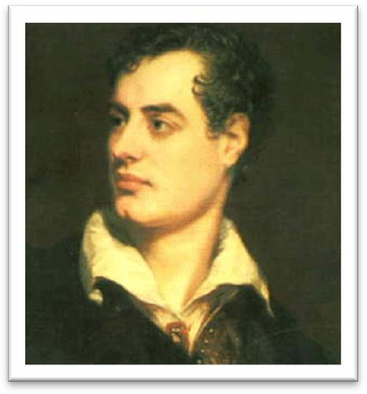 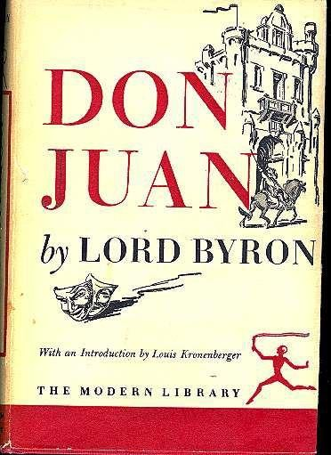

# He earned enormous sums of money and was paid as much as ￡100 for a single appearance.

**earn enormous sums of money**

# Despite this, he was so extravagant that he was always in debt.

* 课文写法替换

…, he was **so** extravagant **that** he always owed people money.

* **课后题**

7． He was so extravagant that he ___B___ people money. (1.20)

(a) always owed to (b) always owed (c) owed always (d) was always owing to

**owe sb sth.** 欠某人某事

* I owe you (one).
* How much do I owe you? 我该付多少钱
* **走遍美国**
* How much do I owe you?
* Well, that'll be eighteen dollars and seventy cents. No charge for the cleanup. It's on the house.

# After he was defeated by a boxer called Gentleman Jackson, he was quickly forgotten.

# He was sent to prison for failing to pay his debts and died in poverty in 1836.

# 总结

**总结**：

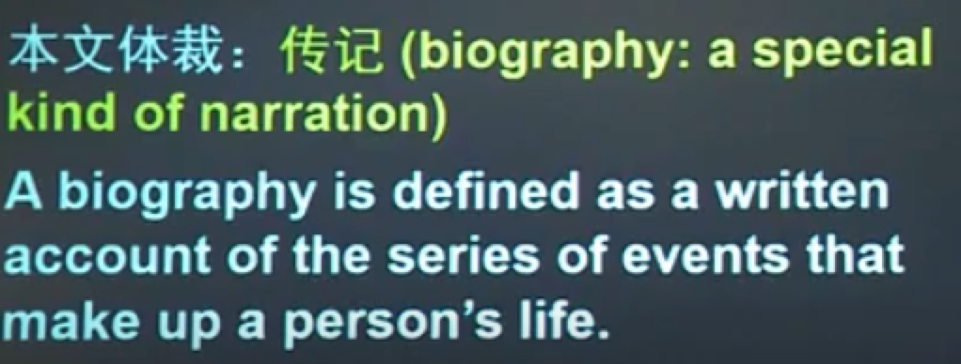

要点：

